**HANDBOOK CZECH NATIONAL TEAM 2016**

*“BIG THING HAPPEN TO WHO BUST THEIR ASS”*

**SERVE PHILOSOFY:**

We serve always to hurt the opponent; serve can be powerful or tactical.

We use always eight seconds to prepare our serve, we focus our target and we repeat in our mind the technical gesture, we avoid all external noises.

**BLOCK AND DEFENSE SYSTEM:**

STARTING POSITION

BLOCK AND DEFENSE

5,5 mt

4,5 mt

2,5 mt

5,5 mt

2,5 mt

6,0 mt

DEFENSE:

Position 6: in the middle of the court and 6 mt. to the net (middle-middle)

Position 1 and 5: 5,5 mt to the net, 2,5 mt to the side lines.

BLOCK:

Position 3 (MB) starts in the middle of the net or one step to the right.

Position 2 and 4 start in helping position (called standard position) that allows the wings to arrive to block their spiker leaving one line.

**OPPONENT SETTING ZONES:**

We divided opponent's court in three different areas, depending on setter's position:

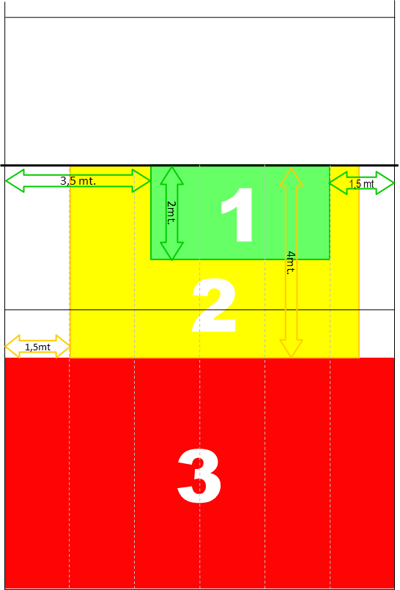

Green Area (1): In this area opponents have four attack solutions, zona 4, zona 2 or 1, first tempo and pipe. We will play according with our game plan; in this area is possible to jump in option block.

Yellow Area (2): In this area we distinguish two situations:

* + The setter is around the line of the three-meter (receiving !) we'll play in reading, priority is always to get two persons block, if the ball is too fast middle blocker leaves hole.
  + The setter shifted to zona 4 (VERSO QUATTRO): the MB adjusts one step to the right, position 4 also fixes a step to the right **(This shift must be before that opponent setter touches the ball, to be quiet at the time of the set)**
  + The setter shifted to zona 2 (VERSO DUE): the MB stays in the middle, position 2 adjusts to the left, position 4 stays in starting position **(This shift must be before that opponent setter touches the ball, to be quiet at the time of the set)**

Red Area (3): In this area the opponents have maximus two attacks solutions: priority three men block, open or close depends on opponent set's speed.

**SYSTEM BLOCK AND DEFENSE**

**THREE MEN BLOCK ON HIGH BALL ATTACK**

All players in defense must stay frontal to the spiker, it means that shoulders line is 90 degrees with the trajectory of the attack.

When we go three men block we always close the line.

6 mt ; 1 mt

standing up

8 mt ; in the middle

6,5 mt

HIGH BALL 3 MEN BLOCK

HIGH BALL 3 MEN BLOCK

6 mt ; 1 mt

standing up

8 mt ; in the middle

6,5 mt

**THREE MEN BLOCK ON HIGH BALL ATTACK WITH HOLE**

6 mt ; 1 mt

standing up

8 mt ; in the middle

6,5 mt left hand of the middle

HIGH BALL 3 MEN BLOCK OPEN

HIGH BALL 3 MEN BLOCK OPEN

6 mt ; 1 mt

standing up

8 mt ; in the middle

6,5 mt right hand of the middle

**2 MEN BLOCK WHEN OPPONENT'S RECEPTION IS ESCLAMATIVA (!)**

**LINE CLOSE**

2 MEN BLOCK LINE CLOSED

6 mt ; 1 mt standing up

6 mt; left hand of the middle

8 mt ; in the middle

4 mt ; out of the block

2 MEN BLOCK LINE CLOSED

6 mt ; 1 mt standing up

4 mt ; out of the block

6 mt; right hand of the middle

8 mt ; in the middle

attack in 2°line: higher position and inside the court

In case of opposite attacks from back row, defense position of our position 2 will be higher and slightly inside the court.

**LINE OPEN**

2 MEN BLOCK LINE OPEN

6 mt ; on the line

8 mt ; in the middle

4 mt ; out of the block

6 mt; left hand of the middle

2 MEN BLOCK LINE OPEN

4 mt ; out of the block

attack in 2°line: higher position and inside the court

6 mt; right hand of the middle

8 mt ; in the middle

6 mt ; on the line

**TWO MEN BLOCK WHEN OPPONENT'S RECEPTION IS GOOD (R#,R+)**

**Middleblockers leave hole**

2 MEN BLOCK HOLE IN THE MIDDLE

6 mt ; on the line

6mt ; in the middle

3mt ; high position ready for tips

5,5mt;

6 mt ; on the line

6mt ; in the middle

3mt ; high position ready for tips

5,5mt;

2 MEN BLOCK HOLE IN THE MIDDLE

**BLOCK SYSTEMS**

Lettura Standard (open hands): Players in 2 and in 4 standing in helping, this position has to be confortable and allows them to arrive blocking their wing spikers leaving open line. Middleblocker stays in reading.

Lettura tre (number three): Players in 2 and in 4 standing in helping, this position is little bit closed. Focus most of all on opponent's first tempo and pipe.

Starting position of player in 2 and in 4 are respectively the same when we play in Lettura 2 and Lettura 4.

Lettura due (numero 2): We suppose that opponent's zona 4 is less used or the ball is slow and we can easily arrive to block.

Usually when opponent's first tempo is shot or double C.

Player in 2 starting position is closer to MB and his priority are to help MB blocking first tempo and pipe.

Player in 4 priority is his wing spiker (zona 2/zona 1)

Middleblocker stays in reading priority is center and right spiker (zona 1/2)

Lettura quattro (numero 4): We suppose that opponent's zona 2/1 is less used or the ball is slow and we can easily arrive to block.

Usually when opponent's first tempo is 1 or 2 or they play a lot of pipe.

Player in 4 starting position is closer to MB and his priority are to help MB blocking first tempo and pipe.

Player in 2 priority is his wing spiker (zona 4)

Middleblocker stays in reading priority is center and left spiker (zona 4)

Lettura W (corna): We suppose that center zone is less used (first tempo and pipe)

Players in 2 and in 4's priority are their respectively wing spiker.

Starting position allows them to arrive blocking wing spikers's first direction.

Middleblocker stays in reading his priority is to close wings block.

Opzione tre (pugno): Starting position like in Lettura Standard.

We suppose that opponent's team will play first tempo

MB jump in option with opponent's MB and close his main direction

Players in zone 2 and 4 play 1vs1 block against their wing spiker.

Opzione due (pugno sx, 2 dx): Starting position like in Lettura 2.

Usually when opponent's team will play shot or double C.

Player in 2 jump in option against opponent's first tempo.

MB reading position against pipe, left side (zona ½) and helps first tempo

Player in 4 priority is his respective wing spiker.

Opzione quattro (pugno dx, 4 sx): Starting position like in Lettura 4.

Usually when opponent's team will play first tempo close.

Player in 4 jump in option against opponent's first tempo.

MB reading position against pipe, right side (zona 4) and helps first tempo

Player in 2 priority is his respective wing spiker.

**RECOVERY SYSTEM ON HIGH BALL SPIKE OR NO PIPE ATTACK**

Setter FAR from the spiker

Setter far from the spiker

RECOVERY ON HIGH BALL ATTACK

SETTER

MB 1° LINE

MB 2°LINE OR LIBERO

OUTSIDE HITTER 1° LINE

OUTSIDE HITTER 2°LINE

MB 1°LINE

MB 2° LINE OR LIBERO

OPPOSITE 1° OR 2° LINE

OUTSIDE HITTER 2° LINE

Setter far from the spiker

RECOVERY ON HIGH BALL ATTACK

SETTER

Setter CLOSE to the spiker

RECOVERY ON HIGH BALL ATTACK

MB 1°LINE

MB 2°LINE OR LIBERO

SETTER

OUTSIDE HITTER 1°LINE

OUTSIDE HITTER 2°LINE

Setter close to the spiker

RECOVERY ON HIGH BALL ATTACK

MB 1°LINE

MB 2° LINE OR LIBERO

SETTER

OPPOSITE 1° OR 2° LINE

OUTSIDE HITTER 2°LINE

Setter close to the spiker

**RECOVERY SYSTEM WHEN SECOND ROW SPIKER GOES FOR PIPE**

**SYSTEM FREE BALL**

RECOVERY WITH OH ATTACKING PIPE

MB IN 1°LINE

LIBERO

SETTER

OPPOSITE IN 1° OR 2°LINE

OUTSIDE HITTER IN 2°LINE

OUTSIDE HITTER IN 2°LINE

SETTER

RECOVERY WITH OH ATTACKING PIPE

LIBERO

MB IN 1° LINE

OUTSIDE HITTER IN 1°LINE

FREE BALL OPPOSITE 2° LINE

OUTSIDE HITTER IN 2°LINE

MB IN 1°LINE

OUTSIDE HITTER IN 1° LINE

LIBERO OR MB IN 2°LINE

OPPOSITE IN 2°LINE

FREE BALL OPPOSITE 1° LINE

POSITION 5

MB IN 1° LINE

OUTSIDE HITTER IN 1°LINE

OPPOSITE

POSITION 6

**PASSING SYSTEM**

This is how we codify passing zones

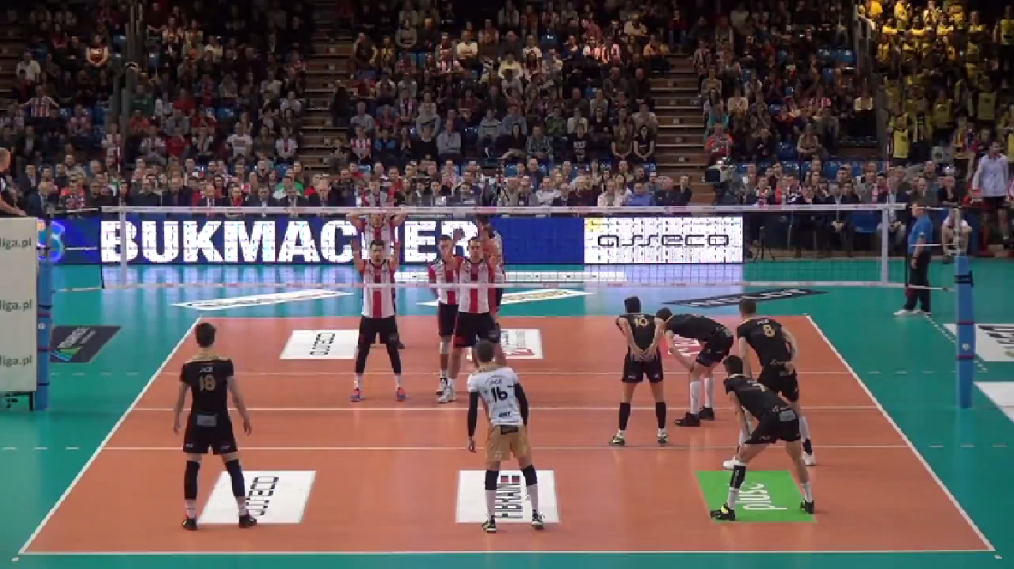

1A

9

7

1

5

6

5D

4

2

3

Float serve: we receive always in 3, short serve into 3 meters line we take with middle blockers

Jump serve: we receive always ins 3, in rotations like P1, P4, P5 we can receive in 4 with opposite’s help

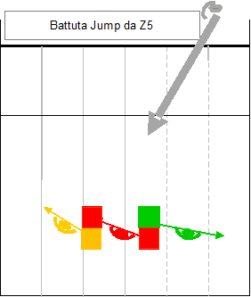

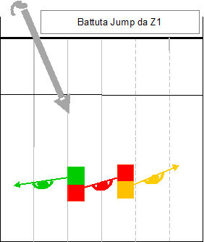

**WHO SET WHEN SETTER MAKES FIRST TOUCH**

Inside the 3 meters line set always the middle in first line.

Outside the 3 meters line set always libero, when libero is not in the court set always the middle in second line.

**HOW HAVE TO BE THE SET:**

* High parabola
* Near to the net
* Inside the court, is better one meter short then 15 centimeters long

*“REMEMBER, EASY THINGS MUST BE PERFECT”*

**ATTACK PHILOSOFY:**

**Spike versus 1 man block:** to look for angles and to go out from the block

**Spike versus 2 men block:** do not close the attack, to spike in the middle if the opponent MB is on late.

**Spike versus 3 men block and high ball:** to play intelligent attack, to attack high; if the ball is far from the net we can attack strong and flat on the blockers’ hands. We can tip behind the block on the setter or on the opposite, in zone 6 in the middle of the court if opponent team’s dig is long in diagonal or we can attack on MB in second line.

**First tempo:** to anticipate, attack long and deep, do not close the attack in 3 meters.